Assignment 5 – Web Design Part 2
We are continuing to work on creating the website for our media company today.
By now you should have these things completed
- Blogger website address
  - It should include your company name
  - https://tgj3mct.blogspot.ca/ (this one is for TDJ3M Communications Technology (CT)
- Header Image
  - You should have a header that includes your logo and/or name.

- About Page
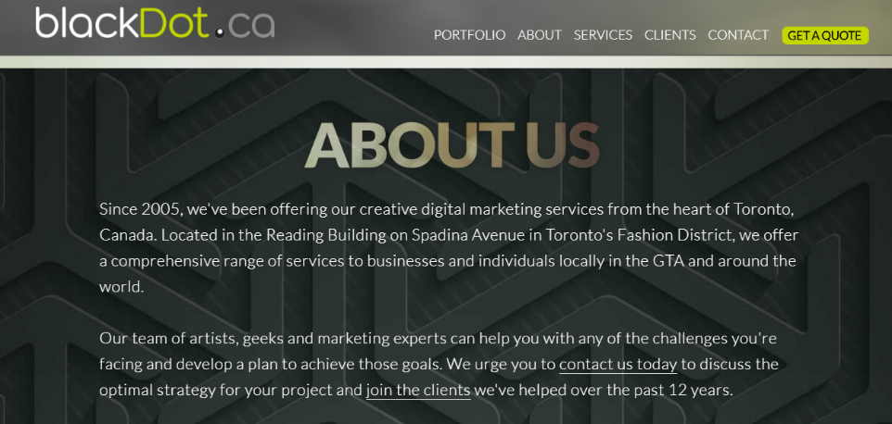
  - You need a paragraph or two about what your company does (photography, animation, sound and video production and editing, and websites

New Pages and Content
Today we will add a Contact page and a Portfolio page.
Assessment
This portion of the website design project will be assessed using the same rubric as we did for Part 1. So, please look at any of the comments your teacher made, plus any of your own ideas to improve your mark.
- Contact Page
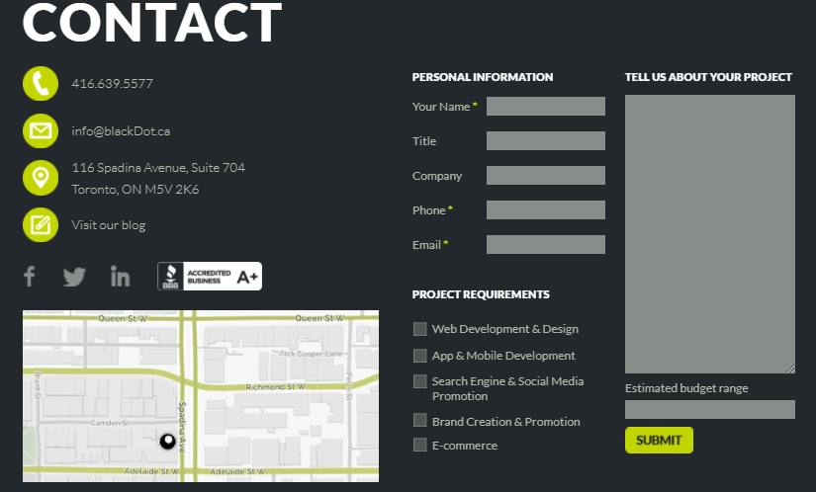
There are many ways for someone to get in contact with a business these days. In the past, we had to go into a store or an office or call them. Now we can use social media and email to get in touch with a company. We can even use a web form. Look at how detailed this contact page is.

It has icons or pictures so you can easily find their phone number, email, address, and website / blog. They even include a map to their office and a web form to for customers to fill in.
You contact page must have some of these elements (but you can include as much as you like). You can also use fake information. (Don’t give away personal details about yourself on the Internet).
- Phone number - (519) 555-5555
- Email - info@yourcompany.com (info@blackdot.ca)
- Pictograms (to show where to find your info)
- Social Media links – these can be fake and simply link to their main page (ie. Facebook.com)
- A picture or a map
Make this page look as attractive as possible. Make sure things are spelled correctly.
- Portfolio Page
Write a paragraph and include an image where you will post all of the projects you will design for this class.
Write something like “We work hard to create quality media products. Check out some of the work we have done below and contact us if you would us to create a memorable media product for you.”
Make sure that “contact us” is clickable and links back to the contact page you just made.

Criteria/Level | R 0-49% | Level 1 50-59% | Level 2 60-69% | Level 3 70-79% | Level 4 80-100%
Application  Formatting and Appearance | The pages are unattractive and/or incomplete. Text is  difficult to read or not present. The backgrounds  are distracting. | The pages are unattractive. Text is difficult to read.  The backgrounds are distracting. | The pages appear "busy" or "dull." Text may be difficult to read. The backgrounds are somewhat  distracting. | The pages are eye-catching and attractive. Text is easy to read. The backgrounds are subtle and appropriate. | The pages are exceptionally attractive. Text spacing and alignment make reading easy.  The backgrounds enhance the page.
Communication  Navigation | There are little to no links for navigation. Links are broken or don’t point in the correct location. A user typically feels lost. | Links for navigation are not clear, several links are broken or point towards the wrong content. | Links for navigation take the reader where s/he expects to go, but some needed links seem to be missing. A user sometimes gets lost. | Links for navigation are clearly labeled, allow the reader to easily move from a page to related pages (forward and back), and internal links take the reader  where s/he expects to go. A user rarely becomes lost. | Links for navigation are clearly  labeled, consistently placed, allow the reader to easily move from a page to related pages (forward and back), and take the reader where s/he expects to go. A user does not become lost.
Inquiry  Graphics | There are no photos, icons or clipart, or they are inappropriate or of low  quality. | Photos are blurry or  fuzzy; icons and clipart do not "fit" with the topic. Too many pictures make the download time slow. | Some photos, icons, and clipart are appropriate and clear. Some graphics do not fit the theme of the site. | Photos, icons, and clipart  are appropriate, of high  quality, and download fairly quickly. | Photos, icons, and clipart are used creatively and effectively follow the site’s theme.
Knowledge  Content | Content is not complete. Text is inaccurate or missing. The pages are illogical and not present. | Content is not related to the theme. Text is unclear and inaccurate. The pages are illogical and in sufficient in number. | Content is somewhat informative. Text is somewhat clear. The pages are sufficient in number. | Content is informative and well written. Text is clear and accurate. The pages are logical and sufficient in number. | Exceptional work. Content is  informative and well written. Text is clear and accurate. The pages are well defined and logical.

