Assignment 4 – Web Design Part 1
You will be creating a website for your media company.
Here is an example from a Toronto based business.
As you can see, they have a logo that looks like a black dot combined with the wi-fi pictogram
They took two of these pictograms and
combined them like this. Then they
connected the first two arcs to form a
circle around the dot. Very creative!
So they now have a symbolic logo. You can see it in the background of the website header below.
They also have a phonetic logo You can see the stylized the dot (.)

The header to this website has their logo repeated over and over again to create a unique design.
They have six pages – 1) Portfolio 2) About 3) Services 4) Clients 5) Contact 6) Get a Quote
For the first part of the website design challenge, you need to design and create a header and create at least three pages. The only page you need to add content to is the “About” page though.
There is an example on the next page.

Here is what an about page could look like.
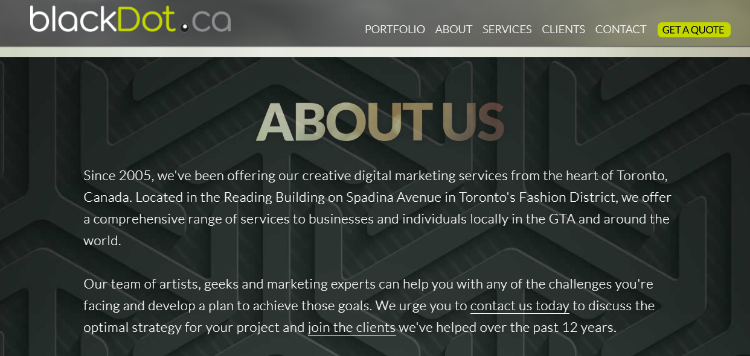

It can be as simple as a paragraph or two. It should include an image (picture) or a fancy background like the one above.
Do these two things for your website and email the address (http://www.blackdot.ca) to your teacher.
Here is the rubric for this portion of the
Criteria/Level | R 0-49% | Level 1 50-59% | Level 2 60-69% | Level 3 70-79% | Level 4 80-100%
Application  Formatting and Appearance | The pages are unattractive and/or incomplete. Text is  difficult to read or not present. The backgrounds  are distracting. | The pages are unattractive. Text is difficult to read.  The backgrounds are distracting. | The pages appear "busy" or "dull." Text may be difficult to read. The backgrounds are somewhat  distracting. | The pages are eye-catching and attractive. Text is easy to read. The backgrounds are subtle and appropriate. | The pages are exceptionally attractive. Text spacing and alignment make reading easy.  The backgrounds enhance the page.
Communication  Navigation | There are little to no links for navigation. Links are broken or don’t point in the correct location. A user typically feels lost. | Links for navigation are not clear, several links are broken or point towards the wrong content. | Links for navigation take the reader where s/he expects to go, but some needed links seem to be missing. A user sometimes gets lost. | Links for navigation are clearly labeled, allow the reader to easily move from a page to related pages (forward and back), and internal links take the reader where s/he expects to go. A user rarely becomes lost. | Links for navigation are clearly labeled, consistently placed, allow the reader to easily move from a page to related pages (forward and back), and take the reader where s/he expects to go. A user does not become lost.
Inquiry  Graphics | There are no photos, icons or clipart, or they are inappropriate or of low  quality. | Photos are blurry or  fuzzy; icons and clipart do not "fit" with the topic. Too many pictures make the download time slow. | Some photos, icons, and clipart are appropriate and clear. Some graphics do not fit the theme of the site. | Photos, icons, and clipart  are appropriate, of high  quality, and download fairly quickly. | Photos, icons, and clipart are used creatively and effectively follow the site’s theme.
Knowledge  Content | Content is not complete. Text is inaccurate or missing. The pages are illogical and not present. | Content is not related to the theme. Text is unclear and inaccurate. The pages are illogical and in sufficient in number. | Content is somewhat informative. Text is somewhat clear. The pages are sufficient in number. | Content is informative and well written. Text is clear and accurate. The pages are logical and sufficient in number. | Exceptional work. Content is  informative and well written. Text is clear and accurate. The pages are well defined and logical.

