LITRES OF LEADERS
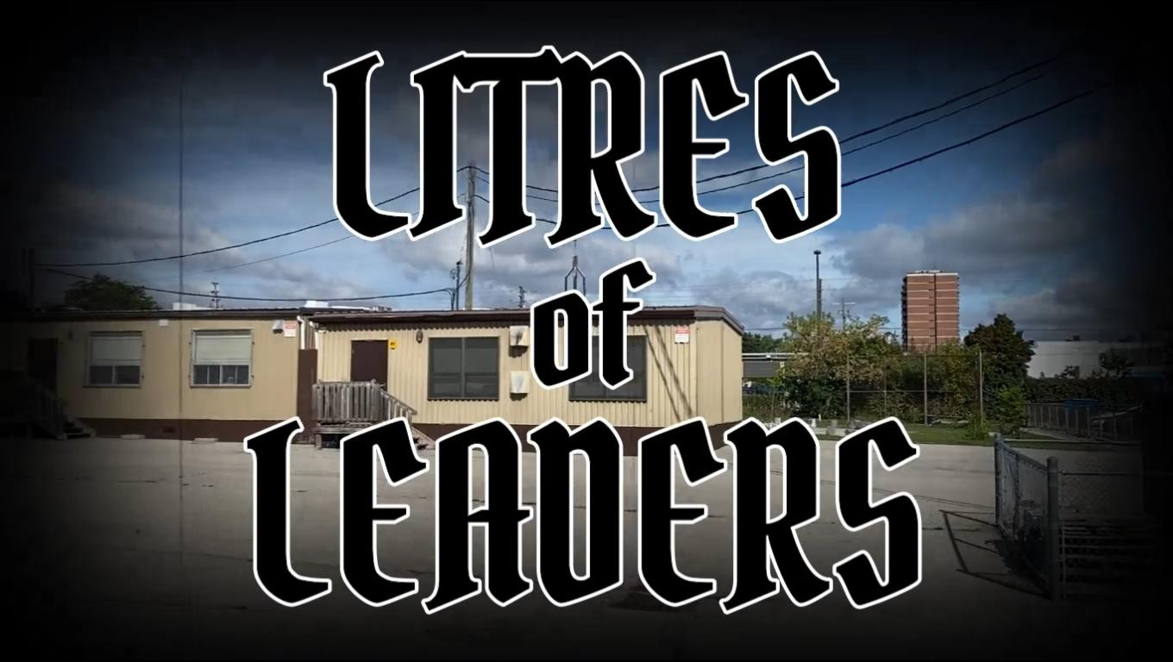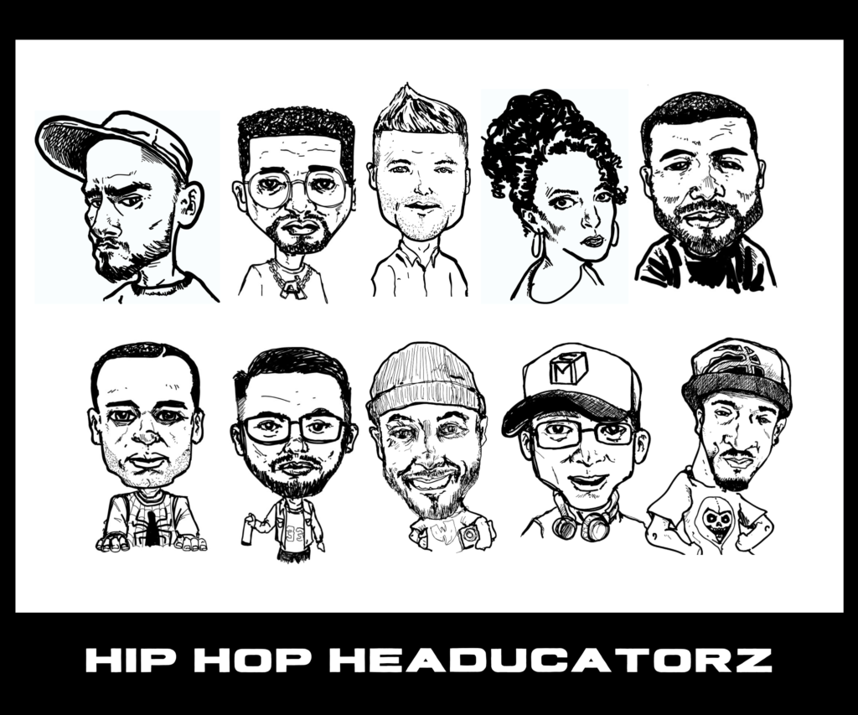
NAME:________________________________

For this activity, you will need to watch the music video “Litres of Leaders” by Hip Hop HeadUcatorz ft Dinco D. You can find it on YouTube or at the following link.

https://youtu.be/27mgGMxkFQ4

- What makes a good leader? Think of characteristics or qualities that some leaders might share?

- What is the overall theme or message of the song? Provide evidence to support your answer.

- What do you think Wizekrak is trying to say in these lyrics?
“It’s more about refining your craft, you better start one/ I don’t follow people like sheep do, they’re not smart son/”

- Chase March raps, “Where the leaders at? Everyone’s just following trends / Time to use your vision, create something different/”
Give an example of people just following trends and what they can do instead, to become a leader.

- Try to identify some of the leaders that are featured in this video. How many can you name? Why do you think those leaders were chosen? You may have to do some research to answer this question.

- Who would you have chosen as a leader to showcase in this video? Justify your choice(s).

Bonus Question

Dinco D was in an influential rap group in the early 1990s. What was the name of his group and how did it influence the theme of this song?

