**GPS**

**(Grade Performance Steps)**

**The Road to Musical Success!**

Recorder Performance Tasks

**YEAR 1**

**Soprano Recorder**





Ontario Music Educators’ Association

[www.omea.on.ca](http://www.omea.on.ca)

**GPS Task Student Evaluation Chart Recorder Performance Tasks: Year 1**

In order to be successful this year, you will need to plan out how many tasks you think you can complete, and the mark you want to receive for performing on your instrument! Below is a summary of the number of tasks per term, and the mark you will receive for the tasks you complete:

|  |  |  |  |  |
| --- | --- | --- | --- | --- |
| **TERM 1 (September – January)** | |  | **TERM 2 (February – June)** | |
| **# of Tasks Completed** | **Grade**  % Letter |  | **# of Tasks Completed** | **Grade**  % Letter |
| 1 | 55% D | 1 | 38% R |
| 2 | 65% C | 2 | 42% R |
| 3 | 68% C+ | 3 | 45% R |
| 4 | 72% B- | 4 | 48% R |
| 5 | 75% B | 5 | 52% D- |
| 6 | 78% B+ | 6 | 55% D |
| 7 | 82% A- | 7 | 58% D+ |
| 8 | 85% A | 8 | 62% C- |
| 9 | 88% A | 9 | 65% C |
| 10 | 92% A+ | 10 | 68% C+ |
| 11 | 95% A+ | 11 | 72% B- |
| 12 | 98% A+ | 12 | 75% B |
| 13 | 100% A+ | 13 | 78% B+ |
| 14 | 14 | 82% A- |
| 15 | 15 | 85% A |
| 16 | 16 | 88% A |
| 17 | 17 | 92% A+ |
| 18 | 18 | 95% A+ |
| 19 | 19 | 98% A+ |
| 20 | 20 | 100% A+ |

Performance is just one part of your Music evaluation this year. Your teacher will let you know what the other aspects of your program are on your two summative report cards.

Remember that with the GPS tasks:

* we will be learning concepts introduced as a class.
* you will have time in class to practice and receive feedback from your teacher and classmates.
* you will have multiple opportunities to demonstrate these tasks.
* you need to demonstrate at least a Level 3 performance (your teacher will talk with you about what a Level 3 demonstration would sound like).
* in order to be successful, you will need to work independently in class, and outside of class time (nutrition breaks and practice at home).

**FINGERING CHART SOPRANO RECORDER**

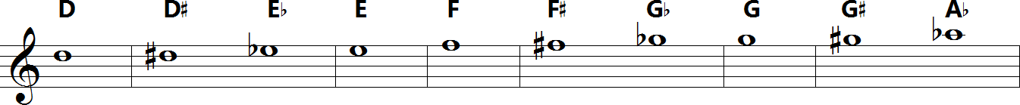

**TASK 1:** FEEL THE BEAT **FOCUS:** PLAYING POSITION / BEAT

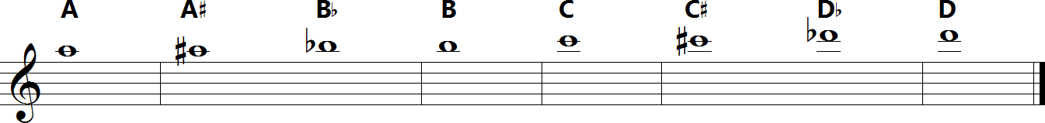

**NOTES:** G

**LEARNING GOAL:** While moving your toe *inside your shoe*, perform the 1st note of the G Major Scale (“G”) for 16 quarter notes. You may breathe as needed. Your teacher will set the *tempo*.

**MINDS ON!** Why is it important to feel the *beat*while playing your instrument? Does the beat change in music or is it the tempo that changes?

**ACTION!** In order to be successful with this task, you will need to:

* Practice the coordination of playing your instrument while moving just your toe – NOT your entire foot.
* Be aware of the *steady beat* and counting to 16.
* Apply this while playing the 1st note of the C Major Scale(“G”).
* Perform this task at the tempo set by your teacher.

**CONSOLIDATION:** In order to move to the next task, you will need to play the note “G” for 16 quarter notes for your teacher while moving your toe inside your shoe.

**Quarter Note Metronome**

Task 1

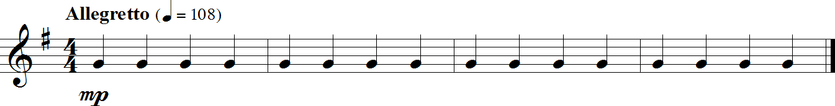Traditional

**TASK 2:** WHITE BELT **FOCUS:** BEAT/RHYTHM

**NOTES:** G, A, B

**LEARNING GOAL:** In this task you will demonstrate your understanding of whole notes, half notes, half rests and quarter notes while playing “Hot Cross Buns”. The following piece of music includes the first three notes of the C Major Scale (“G”, “A” and “B”).

**MINDS ON!** When encountering a new song, why is it important to first scan the entire piece before playing? Don’t forget to maintain good posture and breathing while moving on to more difficult music.

**ACTION!** In order to be successful with this task, you will need to:

* Scan the music for upcoming rhythms and notes, which may need extra practice;
* Scan the music for patterns;
* Keep a steady beat by tapping your toe inside your shoe;
* Demonstrate good posture and breathing**.**

**CONSOLIDATION:** In order to move to the next task, you must perform “Hot Cross Buns” for your teacher and receive feedback.

**Hot Cross Buns**

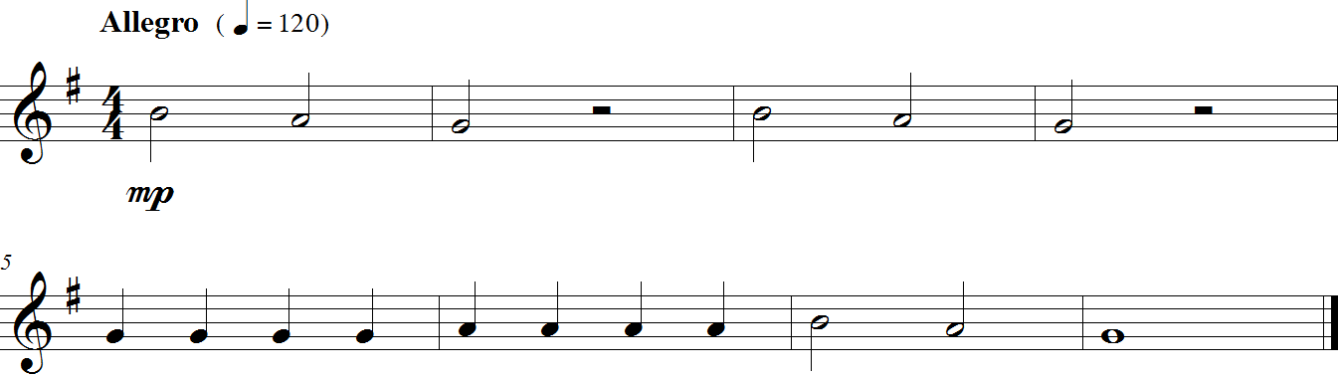Task 2

Traditional

Congratulations on earning your

GPS Recorder **White Belt!**

**TASK 3:** MUSICAL SYMBOLS ON THESTAFF **FOCUS:** NOTATION

**NOTES:** G, A, B, C’, D’

**LEARNING GOAL:** This task will introduce you to the basics of the staff: how to draw a treble clef, a time signature, bar-lines and double bar-lines.

**MINDS ON!** Where does the *clef* sit on the staff? Where does the *time signature* go? Where do you draw bar-lines, and when do you need to draw a double bar-line?

**ACTION!** Before you begin this task you need to:

* Look at other samples of music and determine what symbols are needed to set up a piece of music.
* USE A PENCIL – you might need to correct a mistake!

In order to move to the next task you need to place the following items on the staves below:

1. On the 1st staff, trace over the first step (measure 2) then practice drawing it in the same measure, then do the same for the other 3 steps;
2. On the 2nd staff, draw a treble clef **and** time signature in each of the 5 measures;
3. On the 3rd staff, draw a treble clef and time signature at the front, then draw a bar-line after each note;
4. On the 4th staff, draw a treble clef ONLY, a bar-line after each note except for the last note, where you must draw a double bar-line;
5. Finally, label each of the 8 whole notes below (letter names) in capital letters.

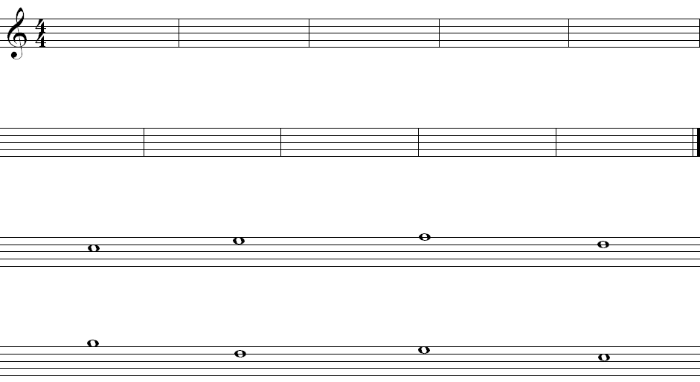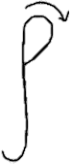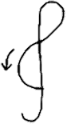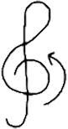

**_______ _______ _______ _______**

**_______ _______ _______ _______**

**CONSOLIDATION:** Show this task for your teacher to receive feedback.

**TASK 4:** YELLOW BELT **FOCUS:** PITCH

**NOTES:** G, A, B

**LEARNING GOAL:** Put the knowledge you have learned about Beat and Rhythm together. You will need to show both the beat and the rhythm of a song.

**MINDS ON!** You have been learning about beat and rhythm as part of the element, duration. In music, both beat and rhythm occur simultaneously which is why some people confuse them. Can you keep the beat with your toe inside your shoe while playing the melody on your recorder?

**ACTION!** In order to be successful with this task, you will need to:

* Practice playing “Au Claire de la Lune” on your recorder until you can play it smoothly;
* Play the rhythm of the song accurately while keeping a steady beat with your big toe inside your shoe;
* Play for a friend and ask them to listen and give you feedback that will help your playing. Do the same for them.

**CONSOLIDATION:** In order to move onto the next tasks, you mustperform “Excerpt from ‘Au Clair de la Lune’” for your teacher and receive feedback.

**Excerpt from ”Au Clair de la Lune”**

Task 4

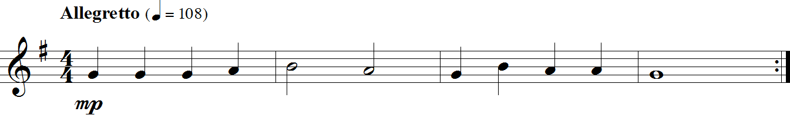French Folk Song

Congratulations on earning your

GPS Recorder **Yellow Belt!**

**TASK 5:** 2-BAR RHYTHM COMPOSITION **FOCUS:** PITCH / RHYTHM / COMPOSITION

**NOTES:** G, A, B, C’, D’

**LEARNING GOAL:** You will perform a rhythmic pattern that you create using quarter notes (ta: ), and eighth notes (ti-ti: ).

**MINDS ON!** Rhythm is an aspect of the element called [duration](http://www.edu.gov.on.ca/eng/curriculum/elementary/arts18b09curr.pdf). It is similar to beat except that it is made up of patterns of long and short sounds and/or silences. It is different than beat because beat is made up of a steady repeated pulse. Rhythm changes everything up! Can you create a rhythm? Can a rhythm sometimes sound like the beat? What do you need to do to make a rhythm when you are blowing through the recorder? What do you use to start and stop the sound on the recorder? How do you make long and short sounds and create silences when blowing through the recorder?

**ACTION!** In order to be successful with this task, you will need to:

* Use your tongue to separate each note when playing the recorder. Remember the important steps when playing your notes;
* Remember to keep your beat steady and not too fast;
* Play the note G in quarter notes (ta: ) for 8 beats. Repeat this with the notes A, B, C’ and D’;
* Play the note D’ in eighth notes (ti-ti: ) for 8 beats. Repeat this with the notes C’, B, A and G;
* When you are ready, create an 8-beat rhythm pattern using ta (, quarter) and ti-ti (, eighth); make sure you draw your rhythms upside down like in the exemplar;
* Play your pattern for a friend on the note D’, then on the notes C’, B, A and G; ask them to clap a steady beat to help you while you practice your rhythm.

**CONSOLIDATION:** In order to move onto the next tasks, you mustplay your 8-beat rhythm on your first 5 notes for your teacher and receive feedback.

**Exemplar 8-beat rhythm:**



**Your 8-beat rhythm:**



**TASK 6:** ORANGE BELT **FOCUS:** BEAT / RHYTHM

**NOTES:** G, A, B, C’

**LEARNING GOAL:** This task will have you demonstrate your understanding of the first 4 notes of the G MajorScale (“G”, “A”, “B” and “C”), as well perform in the $\begin{matrix}3 \\ 4\end{matrix}$ time signature.

**MINDS ON!** Why might you want to clap out the rhythm to yourself before playing through this piece? Make sure that you continue moving your toe inside your shoe while practicing this song.

**ACTION!** In order to be successful with this task, you will need to:

* Practice counting in groups of 3;
* Avoid adding extra beats into each measure;
* Play with a steady tempo, even rhythms and correct notes.

**CONSOLIDATION:** In order to complete this task you must perform the following song for your teacher and receive feedback.

**Excerpt from “The Tales of Hoffman” (Barcarolle)**

Task 6

Jacques Offenbach

(1819 – 1880)

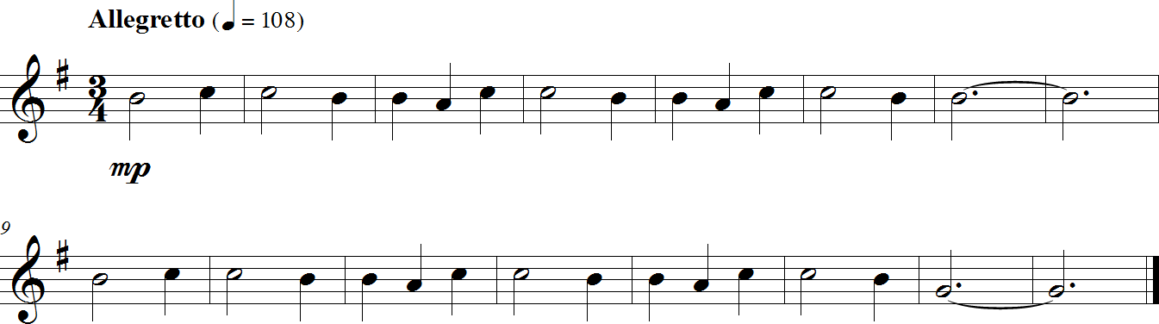

Congratulations on earning your

GPS Recorder **Orange Belt!**

**TASK 7:** 2-BAR PITCHED COMPOSITION **FOCUS:** COMPOSITION / RHYTHM / PITCH

**NOTES:** G, A, B, C’, D’

**LEARNING GOAL:** You will take your 2-bar rhythm composition from **Task 5** and add different pitches to each note, then practice your composition.

**MINDS ON!** Notes can move by step or by leap; which is easier to play? Is it wise to make a composition out of leaps only? Why or why not?

**ACTION!** In order to be successful with this task, you will need to:

* Write out your 8-beat rhythm from **Task 5** in the space below (make sure your rhythms are drawn upside down like in the exemplar of **Task 5**;
* Decide on note names to assign to each note-head of your rhythm and write the letter names above your rhythm (use the notes you know so far: G, A, B, C’ and/or D’);
* Play through your composition, and change any notes you think you might need to;
* Perform your composition for a classmate, and have that classmate fill out the “Peer Assessment”.

**CONSOLIDATION:** In order to complete this task, you must create a 2-bar rhythm, add note names to each of the note heads, perform it for a classmate, and have that classmate fill out the peer assessment below.

**2-Bar Pitched Composition**

Task 7

**Your 8-beat rhythm:**

**Letter names: **



**PEER ASSESSMENT:**

|  |  |
| --- | --- |
| Something done well:  ___________________________  ___________________________ | Something to improve on:  ___________________________  ___________________________  Peer Assessor: __________________________ |

**TASK 8:** RED BELT **FOCUS:** PITCH / RHYTHM

**NOTES:** G, A, B, C’, D’

**LEARNING GOAL:** This task will have you demonstrate your understanding of the first 5 notes of the G MajorScale (“G”, “A”, “B”, “C” and “D”), and introduce you to the ti-ti rhythm within a piece of music.

**MINDS ON!** When tapping your foot to the beat, does a ti-ti rhythm sound quicker or slower than the beat? What could be some good ways to practice getting the rhythm of a song correct before you even add the notes?

**ACTION!** In order to be successful with this task, you will need to:

* Practice performing the rhythm of the song below to a steady beat;
* Determine where some difficult spots are in the song, and practice them in small chunks, starting very slow, and then increasing the tempo;
* Perform the song below with a steady beat, correct rhythms and notes, and good playing position and posture.

**CONSOLIDATION:** In order to complete this task, you must perform “Jingle Bells” for your teacher and receive feedback.

**Jingle Bells**

Task 8

James Lord Pierpont

(1822 – 1893)

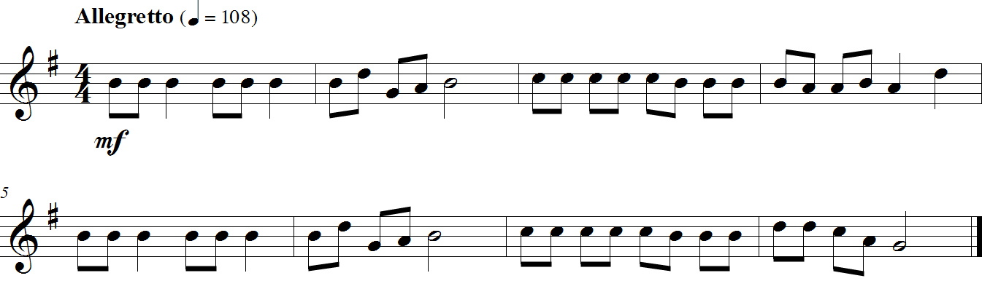

**TASK 9:** MINI RECITAL! **FOCUS:** PERFORMANCE / EXPRESSIVE CONTROLS

Congratulations on earning your

GPS Recorder **Red Belt!**

**NOTES:** D, E, G, A, B, C’, D’

**LEARNING GOAL:** In this task you will choose two recorder belt songs (white, yellow, orange, red or green) to perform for a parent, guardian, sibling, or group of family members.

**MINDS ON!** What might a recital look like? There are many things to consider when preparing a concert, no matter how large or small. Where will you perform? How will you introduce yourself and your selected songs? Will you use your sheet music or will you have it memorized?

**ACTION!** In order to be successful with this task, you will need to:

* Perform for a parent, guardian, sibling, or group of family members, choosing two of the following pieces:
  + White Belt: “Hot Cross Buns”; Yellow Belt: “Au Claire de la Lune”, Orange Belt: “Excerpt from ‘The Tales of Hoffman’ (Barcarolle)”, Red Belt: “Jingle Bells”, Green Belt: “Red River Valley”;
* Explain how you will set up your mini recital in the space provided below;
* After your performance, have a parent, guardian, sibling or other family member complete the “Audience Feedback” form below.

**CONSOLIDATION:** In order to complete this task, you must complete the setup form below, perform two recorder belt songs for a family member, and have them complete the “Audience Feedback” form.

**Audience Feedback Form**

Completed by:

List 3 things you liked about the mini recital:

1.

2.

3.

**Mini Recital Setup**

2 songs I will perform:

Where I will perform:

Who I will perform for:

Will I memorize my songs or use my sheet music?

**TASK 10:** GREEN BELT **FOCUS:** EXPRESSIVE CONTROLS / RHYTHM

**NOTES:** D, E, G, A, B, C’, D’

**LEARNING GOAL:** In this taskyou will learn how to start a piece that uses pick-up notes (anacrusis). You will also perform different dynamics, including crescendos and decrescendos.

**MINDS ON!** What beat have you typically started a piece of music on? How will you know when to come in at the beginning of a song that has pick-up notes? How do you perform different volumes on your instrument? How can you gradually change from one volume to another?

**ACTION!** In order to be successful with this task, you will need to:

* Practice the rhythms of the piece first: look for any rhythms that you think you might have trouble with and practice clapping, saying, or playing the rhythm(s) on one note;
* Practice your new notes: D and E, making sure that all holes are covered completely;
* Perform the dynamics in the following piece, making sure that there is a difference between *p* (*piano –* soft) and *mf* (*mezzo forte* – moderately loud);

**CONSOLIDATION:** In order to move on to the next task, you will need to perform “Red River Valley” for your teacher and receive feedback.

**Red River Valley**

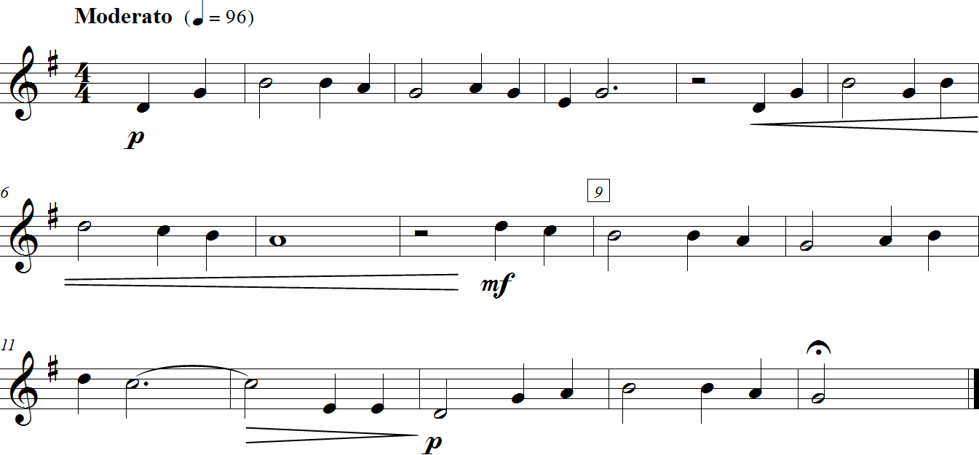Task 10

Folk Song

**TASK 11:** SLIPPERY SLURS **FOCUS:** EXPRESSIVE CONTROLS

Congratulations on earning your

GPS Recorder **Green Belt!**

**NOTES:** D, E, F, G, A

**LEARNING GOAL:** In this task, you will be introduced to the slur, and will need to perform slurred notes using correct articulation.

**MINDS ON!** Where have you seen lines connecting notes before? How did you perform notes that were connected by lines? If notes on different lines or spaces are joined together by a line (known as a slur), how do you think you would perform those notes?

**ACTION!** In order to be successful with this task, you will need to:

* Practice the rhythm of the piece below;
* Perform slurred notes correctly:
  + Articulate the first note of a slur with your tongue;
  + Do not articulate any other notes under the same slur line;
* Practice your new note: F, making sure that all holes are covered completely;
* Perform slurred notes with precise timing of your fingers.

**CONSOLIDATION:** In order to complete this task, you must perform the following song for your teacher and receive feedback.

**Sliding through Slippery Slurs**

Task 11

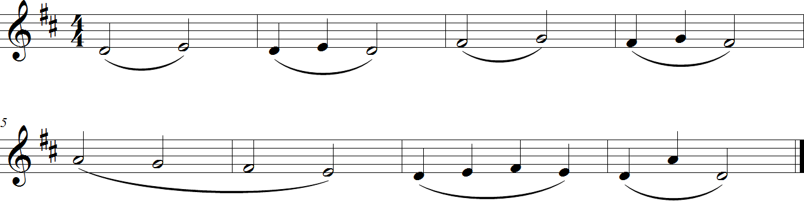

**TASK 12:** BLUE BELT **FOCUS:** EXPRESSIVE CONTROLS

**NOTES:** D, E, F, G, A, B

**LEARNING GOAL:** In this task, you will need to demonstrate your ability to articulate notes that are slurred and those that are not.

**MINDS ON!** What sound do you think of when you articulate your notes? How can you demonstrate the difference between slurred and unslurred notes when practicing the rhythm of a piece of music?

**ACTION!** In order to be successful with this task, you will need to:

* Practice the rhythm of the following piece of music by saying, singing and/or clapping, while at the same time demonstrating the difference in articulations;
* Perform the piece with proper posture, playing position and articulations;
* Perform the piece with the suggested dynamics and tempo.

**CONSOLIDATION:** In order to move on to the next task, you will need to perform “This Old Man” for your teacher and receive feedback.

**This Old Man**

Task 12

Traditional

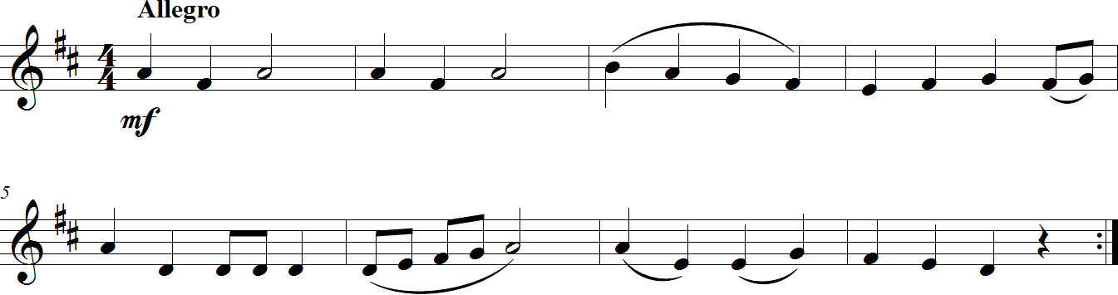

**TASK 13:** MY FIRST COMPOSITION – PART 1: SETUP **FOCUS:** NOTATION

Congratulations on earning your

GPS Recorder **Blue Belt!**

**NOTES:** -

**LEARNING GOAL:** This task will introduce you to the basics of composition: how to set up your staves using all the necessary symbols and musical components.

**MINDS ON!** Think back (or even take a look back) at **Task 3**: where does the *clef* sit on the staff? Where does the *time signature* go?

**ACTION!** Before you begin this task you need to:

* Determine what symbols are needed to set up a piece of music by looking at **Task 3**, as well as other pieces you’ve come across so far.
* Practice drawing your appropriate *clef* on the *staff*.
* USE A PENCIL – you may need to move things around when you enter the notes.

In order to move to the next task you need to place the following items on the staves below:

1. A *treble* *clef* on both staves.
2. A 4/4 *time signature* on the first staff only.
3. Create 8 empty *bars* of music – 4 on the top and 4 on the bottom.
4. A *double bar line* at the end of the piece.
5. Don’t fill in your title just yet!

**________________________________**

Title

Composed by ________________­­­­______________

_____________________________________________________________________________________________________________________________________________________________________________________________________________________________________________________________________________________________________________________________________________________________________________________________________________________________________________________________________________________________________________________________________________________________________________________________________________________________________________________________________________________________________________________________________________________________________________________________________________________________________________________________________________________________________________________________________________________________

_____________________________________________________________________________________________________________________________________________________________________________________________________________________________________________________________________________________________________________________________________________________________________________________________________________________________________________________________________________________________________________________________________________________________________________________________________________________________________________________________________________________________________________________________________________________________________________________________________________________________________________________________________________________________________________________________________________________________

**CONSOLIDATION:** Show this task for your teacher to receive feedback.

**TASK 14:** PURPLE BELT **FOCUS:** RHYTHM / EXPRESSIVE CONTROLS

**NOTES:** D, G, A, B, C’, D’

**LEARNING GOAL:** In this task you will be introduced to a new rhythm, “tam-ti”, as well as reviewing some dynamic markings, including the *crescendo* and *decrescendo*.

**MINDS ON!** When you’re singing, how do you make your voice get louder or softer? How would you gradually change the volume of your playing on the recorder from soft to loud, or from loud to soft?

**ACTION!** In order to be successful with this task, you will need to:

* Practice saying, clapping, and/or singing the rhythm of the piece below with the different dynamic markings;
* Perform the piece with proper notes, rhythms, articulations, dynamics and phrasing.

**CONSOLIDATION:** In order to move on to the next task, you will need to perform “Excerpt from ‘Symphony No. 9’ (Ode to Joy)” for your teacher and receive feedback.

**Excerpt from “Symphony No. 9” (Ode to Joy)**

Task 14

Ludwig van Beethoven

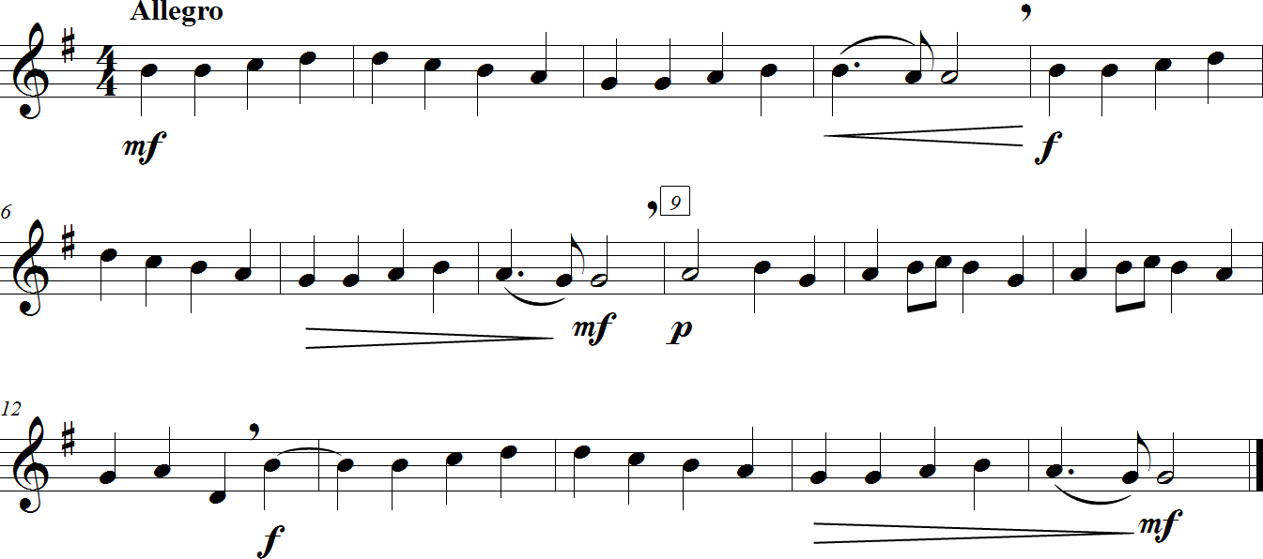(1770 – 1827)

Congratulations on earning your

GPS Recorder **Purple Belt!**

**TASK 15:** SIXTEENTH NOTE RHYTHM READING **FOCUS:** RHYTHM

**NOTES: -**

**LEARNING GOAL:** In this task you will be introduced to 3 different sixteenth-note patterns, and perform 4 of the 16 rhythms chosen by your teacher.

**MINDS ON!** How many beats does a quarter note (“ta”) get in $\begin{matrix}4 \\ 4\end{matrix}$ time? How about two eighth notes (“ti-ti”)? Four sixteenth notes (“tiri-tiri”)? Know the answer to the preceding questions will help you when performing sixteenth note patterns. One of the most important things you can do is keep a steady beat; what is the best way to do this when performing?

**ACTION!** In order to be successful with this task, you will need to:

* Practice each of the 4-beat rhythms below by saying and/or clapping them;
* Draw a small heart under each beat in all 16 rhythms;
* Perform the rhythms while keeping a steady beat.

**CONSOLIDATION:** In order to move on to the next task, you will need to successfully perform 4 of the 16 rhythms below, chosen by your teacher at the time of your assessment.

**16 Sixteenth-Note Rhythms**

Task 15

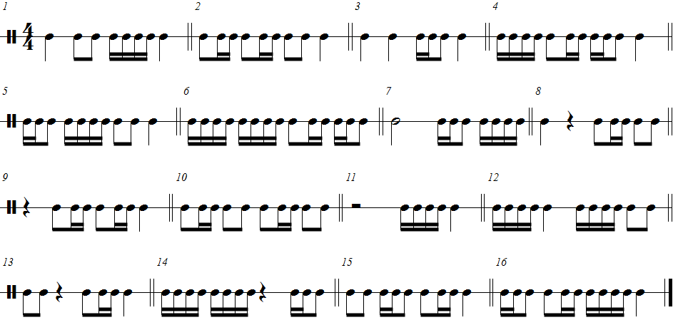

**TASK 16:** BROWN BELT **FOCUS:** NOTATION / RHYTHM / EXPRESSIVE CONTROLS

**NOTES:** D, F, G, A, C', D’

**LEARNING GOAL:** In this task you will be introduced to a new concept: the *key signature*. You will be introduced to a new rhythm, “syn-co-pa”, and a new note, B, and also perform a sixteenth-note pattern you came across in **Task 15**.

**MINDS ON!** A key signature is a group of sharps or flats at the beginning of every staff, just to the right of the clef. What is the purpose of a key signature?

**ACTION!** In order to be successful with this task, you will need to:

* Practice the rhythm of the following piece, particularly in measures 4, 6 and 7;
* Perform the piece with correct notes, rhythms and dynamics.

**CONSOLIDATION:** In order to move on to the next task, you will need to perform “Land of the Silver Birch” for your teacher and receive feedback.

**Land of the Silver Birch**

Task 16

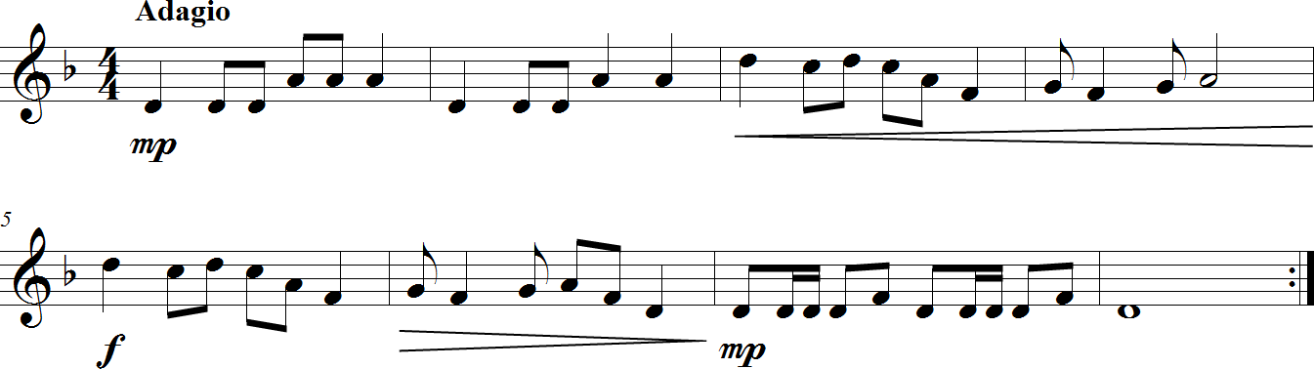Canadian Folk Song

**TASK17:**  MY FIRST COMPOSITION – PART 2: 8-BAR RHYTHM **FOCUS:** RHYTHM / COMPOSITION

Congratulations on earning your

GPS Recorder **Brown Belt!**

**NOTES:** -

**LEARNING GOAL:** The purpose of this task is to create 8 bars of a playable rhythm in $\begin{matrix}4 \\ 4\end{matrix}$ time. Use rhythms with which you are comfortable performing on your recorder.

**MINDS ON!** Why is it important that you are able to play the rhythm that you are writing? Although you may be aware of how to write more difficult rhythm patterns, it is important that you think out the execution of these rhythms.

**ACTION!** In order to be successful with this task, you will need to:

* Decide upon a variety of rhythms that you are able to play on your instrument.
* Create 8 bars of rhythm with a $\begin{matrix}4 \\ 4\end{matrix}$ time signature and write it in the space provided.
* Make sure you use a pencil.
* You do not need to add pitch to these rhythms (yet).

**CONSOLIDATION:** In order to move on to the next task, you will need to complete 8 bars of rhythm in 4/4 time that you or any of your classmates could play. Once written, give this task to your teacher and receive feedback.

**8-Bar Rhythm Exemplar:**

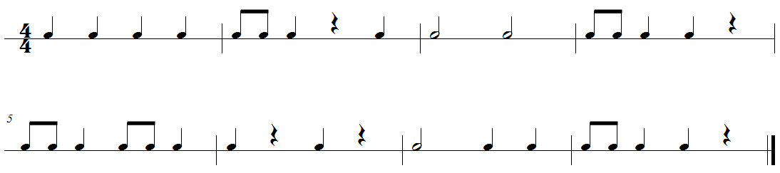

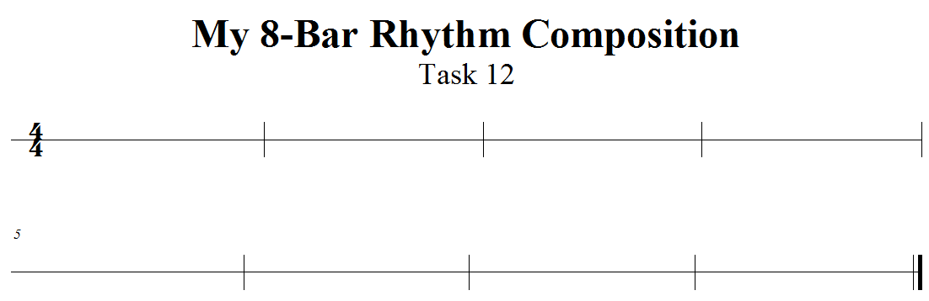**TASK 18:** BLACK BELT **FOCUS:** RHYTHM / PHRASING / EXPRESSIVE CONTROLS

**NOTES:** C, C , D, E, F, G, A, B, B, C'

**LEARNING GOAL:** In this task, you will perform a piece in $\begin{matrix}3 \\ 4\end{matrix}$ time that contains many slurs, new notes, *accidentals*, and the “tam-ti” rhythm introduced in **Task 14**.

**MINDS ON!** Looking at a new piece of music can sometimes be overwhelming. If you were to learn a new piece by breaking the steps down, what would be your first step? What would come next? What is the last thing you would want to think about before performing for an audience, however big or small?

**ACTION!** In order to be successful with this task, you will need to:

* Scan through the piece on the following page, paying attention to things like:
  + Rhythms
  + Key signature
  + Accidentals
  + Articulations
  + Dynamic markings
  + Any other symbols
* Decide how to best approach this piece – consider:
  + Breaking the piece down into smaller sections;
  + Focusing on one element at a time and slowly adding them together;
* Perform the piece with correct:
  + Posture
  + Playing position
  + Rhythms
  + Notes
  + Dynamics
  + Articulations, and
  + Phrasing.

**CONSOLIDATION:** In order to move on to the next task, you will need to perform “Greensleeves” on the following page for your teacher and receive feedback.

**TASK 18 (cont’d):** BLACK BELT **FOCUS:** RHYTHMS / PHRASING / EXPRESSIVE CONTROLS

**NOTES:** C, C , D, E, F, G, A, B, B, C'

**Greensleeves**

Task 18

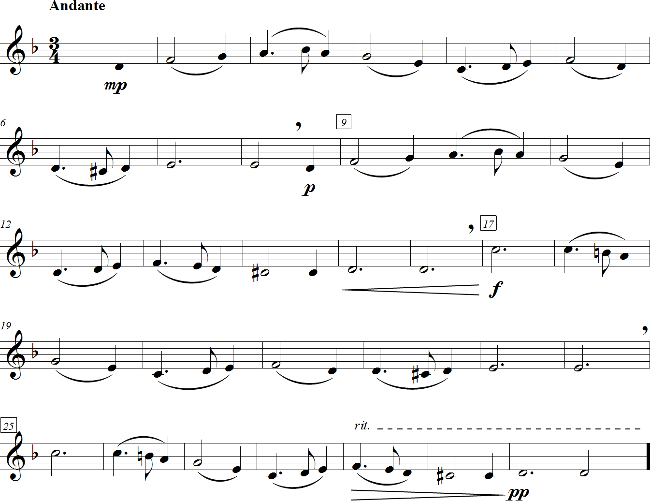English Folk Song

Congratulations on earning your

GPS Recorder **Black Belt!**

**TASK 19:** COMPOSITION – PART 3: NOTATION AND FINISHING TOUCHES **FOCUS:** NOTATION

**NOTES:** ANY NOTES LEARNED THIS YEAR

**LEARNING GOAL:** The purpose of this task is to add *pitches* to your rhythmic composition created in **Task 17**, and then transfer your pitched-rhythms onto the staff you set up in **Task 13.** Finally, add the finishing touches (*dynamics*, *articulation*s, *tempo*) to your composition.

**MINDS ON!** What are the common things you see when looking at printed music? What do you notice about the *stem* directions, the *bar lines*, the beginning and the end of the song, etc.? Have you included all of these elements in your composition?

**ACTION!** In order to be successful with this task, you will need to:

* Use a PENCIL.
* Go to **Task 17** and decide on letter names underneath each notehead.
  + ***CAUTION*:** Remember to use notes that you can play and a pattern that sounds like a melody. Don’t just put in random letter names.
  + ***HINT:*** Starting and ending on the first note of the scale will frame the piece nicely.
* Place the rhythm that you created in **Task 17** onto the staves you prepared in **Task 13**, with the noteheads on the proper lines or spaces (depending on the letters you chose).
* Make sure that you can play what you have written; it’s not about difficulty, it’s about accuracy. ***REMEMBER:*** You can change the notes if you don’t like how it sounds.
* Add the finishing touches:
  + Tempo marking – how fast or slow would you like your composition to be played?
  + Dynamic markings – how loud or soft would you like your composition to be played? You can change the dynamics throughout your composition as well! Take a look at some song examples in your book.
  + Articulations – will all note be articulated? Will some notes be slurred?
* Give your composition a *creative* title.

**CONSOLIDATION:** In order to move on to the next task, you must show your teacher your completed composition, receive feedback. You may also choose to make any changes suggested by your teacher.

**TASK 20:** COMPOSITION – PART 4: GOLD BELT PERFORMANCE **FOCUS:** CUMULATIVE TASK

**NOTES:** ANY LEARNED THIS YEAR

**LEARNING GOAL:** The purpose of this task is to perform your composition for a small group or class as organized and supervised by your teacher.

**MINDS ON!** How are you going to apply the skills that you have developed up to this point? How will your confidence level, preparation and body posture affect your final performance?

**ACTION!** In order to be successful with this task, you will need to:

* Consider the feedback that you received inany of your previous performance tasks – apply that feedback to your final performance.
* With your teacher, organize the time and group for which you will be performing.
* Practice all aspects of your performance: the introduction of your piece, your name, how you will sit or stand, and the music itself.

**CONSOLIDATION:** Perform you composition for the assigned group or class while supervised by your teacher.



Congratulations on earning your

GPS Recorder **Gold Belt!**